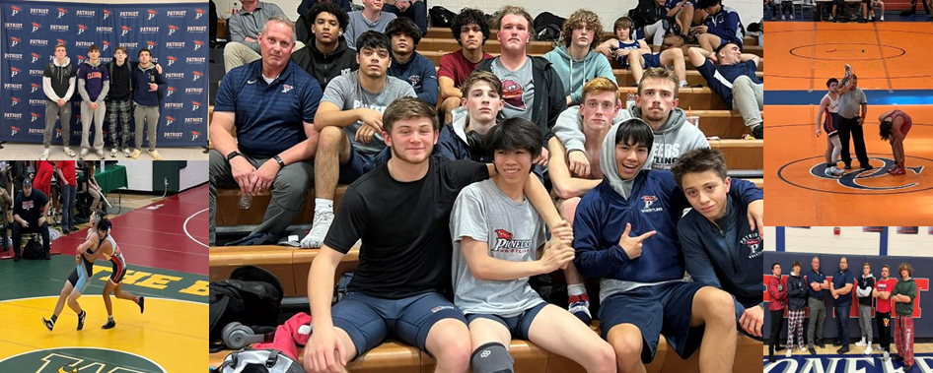

Pioneers Wrestling Interest Meeting
Who: Any/all interested student athletes
What: Wrestling Interest Meeting
When: October 19, 7:00 - 8:00
Where: Aux Gym, enter Door 19

